ICSTTE 2021 Registration Form
2021 5th International Conference on SmartRail, Traffic and Transportation Engineering(ICSTTE 2021)
September 17-19, 2021| Frankfurt, Germany | www.icstte.org
NOTE: Please send the required documents: 1. final paper(doc&pdf), 2. filled registration form, 3. Payment Voucher to icstte@iased.org. (Mail Subject: Paper ID+Registration).
- ATTENDEE INFORMATION

1-inch-Photo here
*Full Name:
*Position√: Prof. □  Assoc. Prof. □  Asst. Prof. □ Dr. □  Mr. □  Ms. □
*Affiliation & Nation:
*Nationality:
*Email: *Mobile Phone:
Emergency Contact(Name&Mobile):
Postal Address& Zip Code (for post use):
Catering Service(Sept. 18)√: Lunch □ Dinner □
Special dietary√: Diabetic □ Vegetarian □ Halal food □ Other □ (please specify: )
Special requirements:

- PAPER INFORMATION
*Paper ID: *Paper Pages: *Additional Page:
*Paper Tile:
*Authors:
*Will you attend the conference Yes □ No □
*Presentation Type√: Oral □ Poster □ Remote Video □ Video □
Student ID No.(student only):
IASED Member No.(member only):
* Receipt Issued to:
- REGISTRATION FEE(by US dollar)
Category | Early  (Until May 20) | Regular  (Until June 25) | Late  (After June 25) | On-site  (Sept 17-18) | Online Presentation  (due by Sept 17) | Your choice
IASED Member  (Author) | USD 500 | USD 550 | USD 600 | USD 650 | USD 350
Nonmember  (Author) | USD 550 | USD 600 | USD 650 | USD 700 | USD 380
Student(Author) | USD 480 | USD 520 | USD 550 | USD 600 | USD 320
One Day Program | USD 400 | USD 450 | USD 500 | USD 550 | USD 250
Listener | USD 300 | USD 350 | USD 400 | USD 450 | USD 200
Social Networking Event | TBD
Academic Visit Optional | TBD

Extra Item | Cost | Your Choice
Extra Page/Per page | USD 70
Extra Paper Upload | USD 370
Extra Banquet Ticket | USD 50
*Notice
*Ordinary length limits is 5-10 pages per paper, If the paper exceeds 6 pages, the additional pages will be charged.
*All the papers will be published on-line.
*For "No shows", registration fee is nonrefundable.
*Cancellation policy: A written refund/cancellation request received by 30 March 2021 can be accepted and a US$100 administrative fee will be charged. After 30 March 2021, the refund/cancellation request will not be accepted.
*Our payment system will not charge any extra fee, but the credit card payment may incur few exchange commission fee which is charged by payers' bank, it should be borne by payers.
*One day program fee covers: Attend meeting sessions on Sept 18+ 2 coffee breaks,1 lunch, 1 dinner on Sept 18+conference kits.
*Full registration fee covers :(Author only) publication fee + meeting sessions on Sept 17-19 + 2 coffee breaks,1 lunch, 1 dinner on Sept 18 + conference kits.

- PAYMENT INFORMATION
URL of of official Online Payment System:
http://meeting.yizhifubj.com.cn/web/main.action?meetingId=351
* The system accepts VISA /Master for payment, please calculate the amount before payment.
Please fill your E-mail address used for payment and Confirmation Number you received after paying.
E-mail: | Confirmation Number:
* As the system will intercept the email address for multiple payments, it is recommended to use different email for each payment
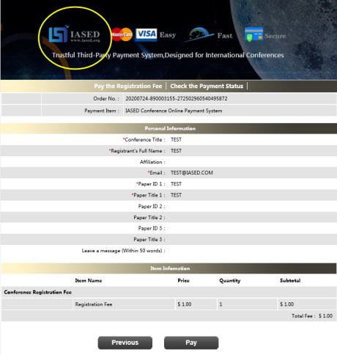
*Please make sure the conference organizer, IASED’s logo is always appear on the page until you click “ Pay”. Then you will be directed to payment page.

- IASED MEMBER APPLICATION
Join IASED now to enjoy the Member Registration Rate. Please compile and return the Membership Form along with your CV to membership@iased.org. Your application will be processed in 5 working days.
- OTHER
Finally, we suggest you write down a biographical sketch here, for use of making introductions by Session Chair before your presentation gets started.
20-120 Words(1-6.5 lines)

ICSTTE 2021 Conference Committee
Frankfurt

